Annual Quality Assurance Report (AQAR)
For the year 2017-18

TRACKID: KLCOGN 16785

Submitted to

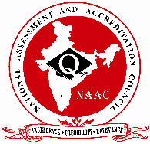

NATIONAL ASSESSMENT AND ACCREDITATION COUNCIL
An Autonomous Institution of the University Grants Commission

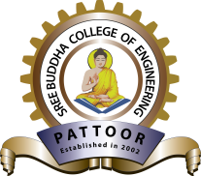
Sree Buddha College of Engineering
Pattoor, Alappuzha - 690529, Kerala.
www.sbce.ac.in, Email: sreebuddha@ktu.edu.in
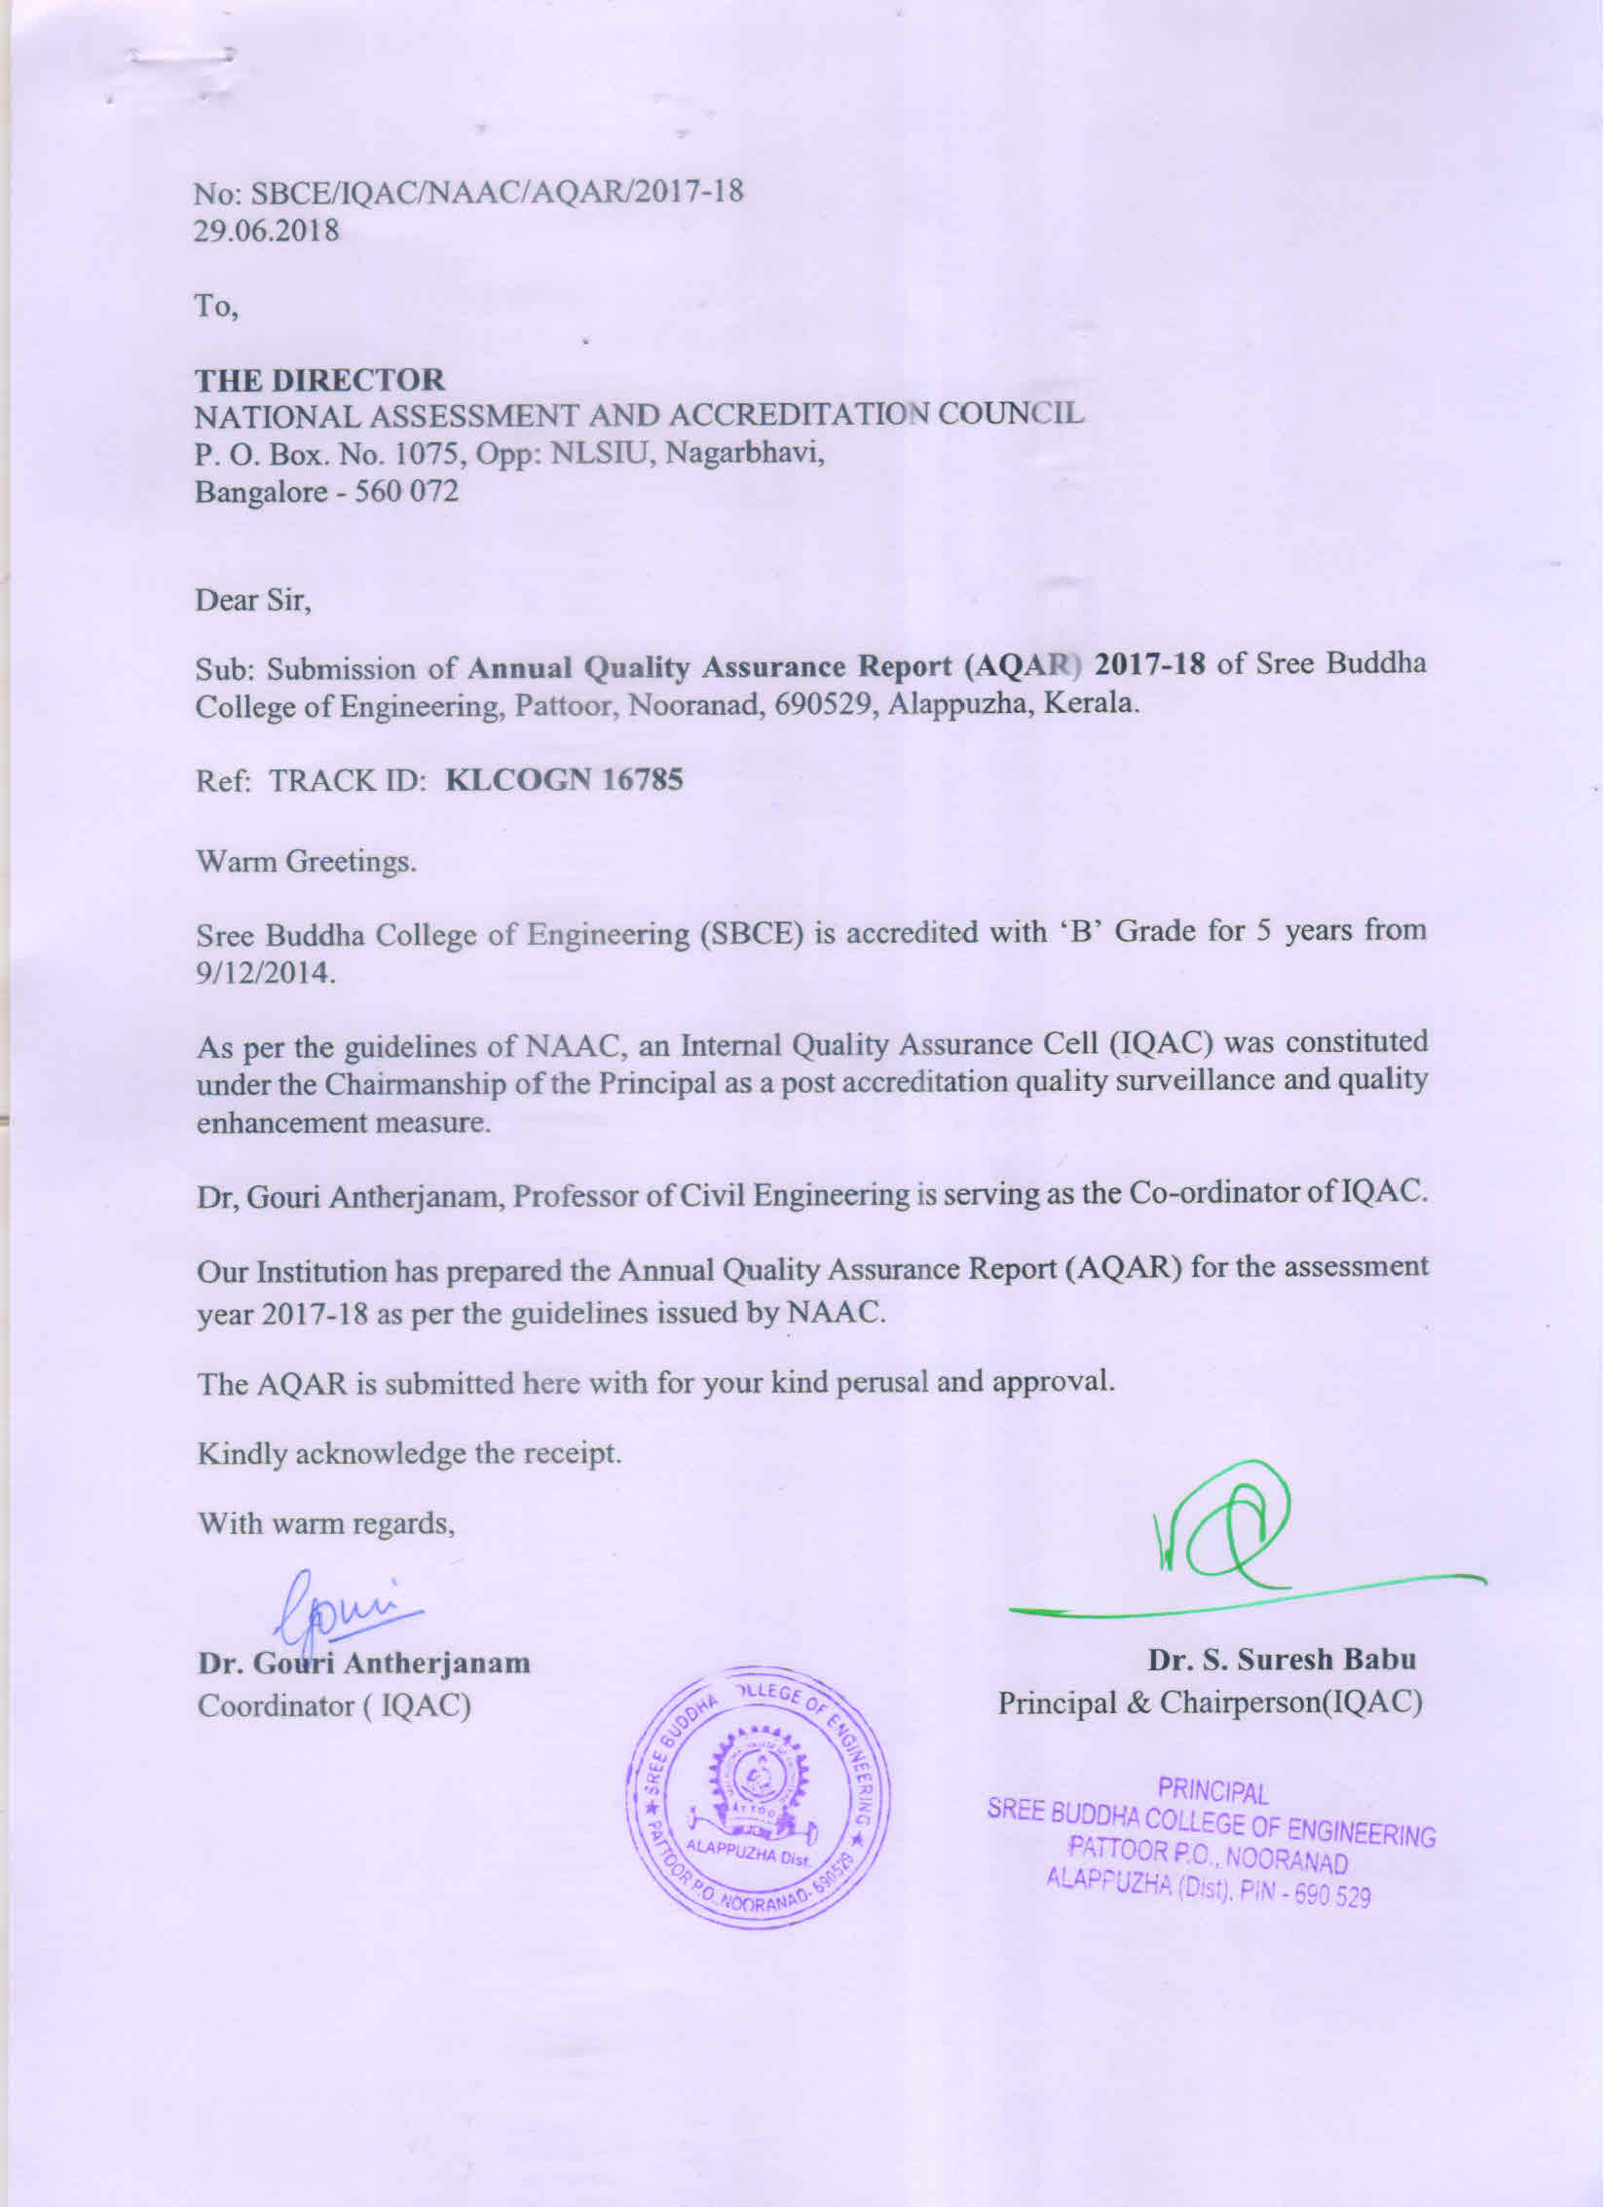

TABLE OF CONTENTS
Sl. No. | CONTENTS | PAGE No.
 | PART-A  Details of Institution | 01
 | CRITERION I  Curricular Aspects | 08
 | CRITERION II  Teaching, learning and Evaluation | 09
 | CRITERION III  Research, Consultancy & Extension | 13
 | CRITERION IV  Infrastructure & Learning Resources | 18
 | CRITERION V  Student Support & Progression | 19
 | CRITERION VI  Governance, leadership & Management | 25
 | CRITERION VII  Innovations & Best Practices | 32
 | ANNEXURE I- Academic Calendar (ODD Semester) | 39
 | ANNEXURE II- Academic Calendar (EVEN Semester) | 40
 | ANNEXURE III- Feedback Analysis | 41

PART – A
1. DETAILS OF THE INSTITUTION
Sree Buddha College of Engineering
1.1 Name of the Institution
1.2 Address Line 1
Pattoor Post
Padanilam, Nooranad
Address Line 2
Alappuzha District
City/Town
Kerala
State
690529
Pin Code
sreebuddha@ktu.edu.in
Institution e-mail address
0479 2375440

Contact Nos.
Dr. S. Suresh Babu
Name of the Head of the Institution:
0479-2375440
Tel. No. with STD Code:
9447266626
Mobile:

Name of the IQAC Co-ordinator:
Dr. Gouri Antherjanam

Mobile:
9446112617
sbceiqac@gmail.com
IQAC e-mail address:

1.3 NAAC Track ID
KLCOGN 16785

EC(SC)/04/A&A/06, dated 10-12-2014
1.4 NAAC Executive Committee No. & Date:

1.5 Website address:
http://www.sbce.ac.in
http://www.sbce.ac.in/naac
Web-link of the AQAR:
1.6 Accreditation Details:
Sl. No. | Cycle | Grade | CGPA | Year of Accreditation | Validity Period
1 | 1st Cycle | B | 2.58 | 2014 | 5 Years

06/09/2008
1.7 Date of Establishment of IQAC:

2017-2018
1.8 AQAR for the year

1.9 Details of the previous year’s AQAR submitted to NAAC after the latest Assessment and Accreditation by NAAC ((for example AQAR 2010-11submitted to NAAC on 12-10-2011)
- AQAR 2014-15 submitted to NAAC on 08-12-15
- AQAR 2015-16 submitted to NAAC on12-05-2016
- AQAR 2016-17 submitted to NAAC on30-06-2017
1.10 Institutional Status

University State Central Deemed Private
Affiliated College Yes No

Constituent College Yes No

Autonomous college of UGC Yes No

Regulatory Agency approved Institution Yes No
(eg. AICTE, BCI, MCI, PCI, NCI)

Type of Institution Co-education Men Women

Urban Rural Tribal

Financial Status Grant-in-aid UGC 2(f) UGC 12B

Grant-in-aid + Self Financing Totally Self-financing

1.11 Type of Faculty/Programme

Arts Science Commerce Law PEI (Phys Edu)

TEI (Edu) Engineering Health Science Management

Others (Specify)
1.12 Name of the Affiliating University (for the Colleges)

APJ Abdul Kalam Technological University

1.13 Special status conferred by Central/ State Government-- UGC/CSIR/DST/DBT/ICMR etc
Under Section | Date, Month & Year
i. 2 (f) | F.No.8-599/2012(CPP-I/C) dated 13-02-2013

Autonomy by State/Central Govt. / University
University with Potential for Excellence UGC-CPE
No

No

No

DST Star Scheme UGC-CE
No

No

No

UGC-Special Assistance Programme DST- FIST
No

UGC-Innovative PG programmes Any other
No

(Specify)
No

UGC-COP Programmes

2. IQAC Composition and Activities
2.1 No. of Teachers
02
15
2.2 No. of Administrative/Technical staff
02
2.3 No. of students
03
2.4 No. of Management representatives
06
2.5 No. of Alumni
2. 6 No. of any other stakeholder and
01
Community representatives
01
2.7 No. of Employers/ Industrialists

2.8 No. of other External Experts
01
2.9 Total No. of members
09
31
2.10 No. of IQAC meetings held

2.11 No. of meetings with various stakeholders:
Faculty | 10 | Non-Teaching Staff | 4 | Students | 2 | Alumni | 1 | Others | NIL

2.12 Has IQAC received any funding from UGC during the year? Yes No

If yes, mention the amount
2.13 Seminars and Conferences (only quality related)
(i) No. of Seminars/Conferences/ Workshops/Symposia organized by the IQAC
02

0
6
0
08
Total Nos. International National State Institution Level
(ii) Themes
- Teaching Pedagogy for faculty members in collaboration with ICT academy of Kerala
- National workshop on Experimental Techniques & Optimization techniques for research
- Faculty development program of learning management system
- National Conference on Advances in Civil Engineering (ACE 2018)
- National Conference of Recent Advances in Mechanical Engineering
- National Conference on Emerging Trends in Green Electrical Technologies (NCETGET 2018
- National Conference on VLSI & Embedded Systems Technology Advancements (VESTA 18’)
- National Conference on Advanced Computing and Communication (NCACC 2018
- National Conference on Technological Advancement in Bioengineering (NCTAB 2018)
- Faculty Development Programs in all departments
2.14 Significant Activities and contributions made by IQAC
- To cater to the changing needs of the industry, new professional electives have been introduced as per University syllabus.
- Up gradation of laboratory infrastructure to strengthen the existing laboratory facilities.
- Invited lectures/workshops/Industrial visits/internships were given to improve practical exposure.
- Awareness programs were held on “how to write research papers and proposals” to improve quality of journal publications and research proposal.
- The entire campus is Wi-Fi enabled and internet is available round the clock in all departments, hostels and laboratories to facilitate research and academic related activities.
- Academic audit process ensure that Student Support Services are given prime importance, which focus on academic performance of the students.
- Outcome Based Education (OBE) is implemented at teaching and learning initiatives, examination evaluation, research, industry interactions etc.,
- Effective use of NPTEL courses by our institute’s Chapter was ranked AAA in NPTEL Online Course Certification Examinations in 2017.
- Academic audit of all the departments
- Monitoring the accreditation activities
- Facilitating teaching and non teaching staff training programs.
- Conducted periodic meeting / discussions with faculty members to collect the data pertaining to various activities of the departments.
- Encouraging departments to organize seminars / workshops / conferences.
- IQAC is interacting continuously with various department coordinators for collecting and collating qualitative & quantitative date from each department.
- IQAC has ensured regular monitoring the activities of the institute and improve access to data across.
2.15 Plan of Action by IQAC/Outcome
The plan of action chalked out by the IQAC in the beginning of the year towards quality enhancement and the outcome achieved by the end of the year *
Plan of Action | Achievements
Effective implementation of OBE | Course delivery sessions are planned as per the requirements of Outcome Based Education. Course delivery is monitored regularly and action is taken to align it with planned sessions.
Effective implementation to qualifying UG programs for accreditation | NBA Accreditation work is in Progress.
Upgrade the skills and competencies of faculty and staff through training programs/conferences/paper publications | Awareness and training sessions were held through research council of the institute to promote quality journal publications and research proposals.
Extend further the laboratory facilities for consultancy work | Upgradation of laboratory facilities for consultancy work
Utilization of departmental budget | Department management committee plan and utilize the budget allocated to improve laboratory and research facilities.
Research Council to Strengthen R&D activities | Seed money provided to faculty members to initiate R& D activities
Developing IPR, centre of excellence . | Setting up an IPR center has been initiated.
To increase the number of Ph.D. holders | With the increase in the number of doctoral degree recipients, the college is now having 20% of PhD holders in total faculty strength.
* Attach the Academic Calendar of the year as Annexure.

Yes |  | No
2.16 Whether the AQAR was placed in statutory body
NIL
NIL

Management Syndicate Any other body
Provide the details of the action taken
- The management and IQAC members approved the Annual Quality Assurance Report (AQAR) deliberation within the cell. The follow-up were carried out periodically through the meetings.
- Faculty members were advised to apply for research grants.
- Faculty members were persuaded for quality research publication.

CRITERION – I

1. CURRICULAR ASPECTS

1.1 Details about Academic Programmes
Level of the Programme | Number of existing Programmes | Number of programmes added during the year | Number of self-financing programmes | Number of value added / Career Oriented programmes
PhD | 1 | 2 | 3 | NA
PG | 6 | NIL | 6 | NA
UG | 6 | NIL | 6 | NA
PG Diploma | NIL | NIL | NIL | NA
Advanced Diploma | NIL | NIL | NIL | NA
Diploma | NIL | NIL | NIL | NA
Certificate | NIL | NIL | NIL | NA
Others | NIL | NIL | NIL | NA
Total | 13 | 2 | 15 | NA

Interdisciplinary | NA | NA | NA | NA
Innovative | NA | NA | NA | NA

1.2 (i) Flexibility of the Curriculum: CBCS/Core/Elective option / Open options
(ii) Pattern of programmes:
Pattern | Number of programmes
Semester | 15
Trimester | NA
Annual | NA

1.3 Feedback from stakeholders* Alumni Parents Employers Students

(On all aspects)

Mode of feedback : Online Manual Co-operating schools (for PEI)
*Please provide an analysis of the feedback in the Annexure

1.4 Whether there is any revision/update of regulation or syllabi, if yes, mention their salient aspects.
No, From 2015 onwards, APJ Abdul Kalam Kerala Technological University regulation is followed
1.5 Any new Department/Centre introduced during the year. If yes, give details.
Yes, BioCare Center under Department of Biotechnology, Govt. of India.
CRITERION – II
2. TEACHING, LEARNING AND EVALUATION
2.1 Total No. of permanent faculty
Total | Asst. Professors | Associate Professors | Professors | Others
106 | 84 | 12 | 09 | 01

2.2 No. of permanent faculty with Ph.D.: 17
2.3 No. of Faculty Positions Recruited (R) and Vacant (V) during the year
Asst. Professors |  | Associate Professors |  | Professors |  | Others |  | Total
R | V | R | V | R | V | R | V | R | V
0 | 0 | 9 | 0 | 4 | 0 | 0 | 0 | 9 | 0

2.4 No. of Guest and Visiting faculty and Temporary faculty: NIL
2.5 Faculty participation in conferences and symposia:

No. of Faculty | International level | National level | State level
Attended Seminars/ Workshops | 18 | 33 | 12
Presented papers | 18 | 18 | 32
Resource Persons | 2 | 0 | 10

2.6 Innovative processes adopted by the institution in Teaching and Learning:
- Academic audits (Internal/External) for ensuring continuous improvement
- Blended learning- NPTEL (IITM)
- Usage of Moodle cloud and word press software for teaching,
- Faculty training of blended MOOCs in collaboration with IIT Bombay
- ICT enabled smart class room,
- Digital library
- Peer group learning
- Extension lectures to fill the gap
- Industrial /site visits for students
- Internships during semester breaks
- Promoting Outcome Based Education (OBE)
- Mentoring system: Progress of the students is continuously monitored
- Students are given freedom to choose the elective
- MoUs with industries to bridge the gap between industries and academia.
139 days
2.7 Total No. of actual teaching days during this academic year
2.8 Examination/ Evaluation Reforms initiated by the Institution (for example: Open Book Examination, Bar Coding, Double Valuation, Photocopy, Online Multiple Choice Questions)
- Continuous Internal Evaluation is carried out during the semester with components of tests, assignment, seminar, quiz and mini projects.
- Evaluation of students is spread to entire semester than end of the semester unlike in conventional university system of examination.
- The analysis of outcomes from Internal Examination performance and University Examination indicates the effectiveness of course content and delivering system.
- Question paper for Internal Evaluation is set based on OBE format to assess various outcomes
- Student’s performance is communicated to the parents on a regular basis.

2.9 No. of faculty members involved in curriculum restructuring/revision/syllabus development as member of Board of Study/Faculty/Curriculum Development workshop
06
10
09

83.3
2.10 Average percentage of attendance of students

2.11 Course/Programme wise distribution of pass percentage:

Title of the Programme | Total no. of students appeared | Division
Title of the Programme | Total no. of students appeared | Distinction % | I % | II % | III % | Pass %
B. Tech EEE (2013-17 Batch) | 50 | 8 | 46 | NIL | NIL | 54
B. Tech BT&BCE (2013-17 Batch) | 30 | 3.33 | 40 | 3.33 | NIL | 46.67
B. Tech ECE (2013-17 Batch) | 60 | 5 | 58.33 | 3.33 | NIL | 66.67
B.Tech ME  (2013-17 batch) | 121 | 4.1 | 52 | 6.6 | NIL | 62.8
B. Tech CE (2013-17 Batch) | 62 | 17.74 | 58.06 | 3.22 | NIL | 79
B. Tech CSE (2013-17 Batch) | 49 | 4.08 | 53.06 | NIL | NIL | 57.1
M. Tech ECE (2015-17 Batch) | 13 | 4.18 | 95.12 | NIL | NIL | 100
M. Tech BT&BCE (2015-17 Batch) | 9 | 11.1 | 88.9 | NIL | NIL | 100
M. Tech CSE (2015-17 Batch) | 7 | NIL | 85.71 | NIL | NIL | 85.71
M. Tech ME (2015-17 Batch) | 5 | 40 | 60 | NIL | NIL | 100
M. Tech EEE (2015-17 Batch) | 11 | 22.2 | 78.8 | NIL | NIL | 100
M. Tech CE (2015-17 Batch) | 24 | 12.5 | 87.5 | NIL | NIL | 100
2.12 How does IQAC Contribute/Monitor/Evaluate the Teaching & Learning processes:
- Arrange for Academic Audit of all the Departments.
- Review of the Self-Appraisal of staff member
- Analyse feedback collected from all stake holders and suggest remedial measures
- Arrange for Orientation programmes for all categories of Staff.
2.13 Initiatives undertaken towards faculty development
Faculty / Staff Development Programmes | Number of faculty  benefited
Refresher courses | 50
UGC – Faculty Improvement Programme | 14
HRD programmes | 34
Orientation programmes | 06
Faculty exchange programme | 0
Staff training conducted by the university | 0
Staff training conducted by other institutions | 27
Summer / Winter schools, Workshops, etc. | 33
Others | 02

2.14 Details of Administrative and Technical staff
Category | Number of Permanent  Employees | Number of Vacant  Positions | Number of permanent positions filled during the Year | Number of positions filled temporarily
Administrative Staff | 49 | NIL | 2 | NIL
Technical Staff | 63 | NIL | 1 | NIL
CRITERION – III
3. RESEARCH, CONSULTANCY AND EXTENSION
3.1 Initiatives of the IQAC in Sensitizing/Promoting Research Climate in the institution
- Research council was established
- Faculty members are encouraged to submit research projects to various funding agencies like DST, DBT, BRNS, MOEF, MNRE, AICTE, KSCSTE etc.,
- Seed money given to faculties to initiate research
3.2 Details regarding major projects
 | Completed | Ongoing | Sanctioned | Submitted
Number | 0 | 1 | 1 | 8
Outlay in Rs. Lakhs | 0 | 48.4 | 48.4 | 88.74

3.3 Details regarding minor projects
 | Completed | Ongoing | Sanctioned | Submitted
Number | 0 | 2 | 1 | NIL
Outlay in Rs. Lakhs | 0 | 0.92 | 0.45

3.4 Details on research publications
 | International | National | Others
Peer Review Journals | 09 | 04 | 0
Non-Peer Review Journals | 04 | 0 | 0
e-Journals | 09 | 0 | 0
Conference proceedings | 04 | 86 | 0

3.5 Details on Impact factor of publications:
3
1.2
0.19-4.0
09
Range Average h-index Nos. in SCOPUS

3.6 Research funds sanctioned and received from various funding agencies, industry and other organisations
Nature of the Project | Duration  Year | Name of the  funding Agency | Total grant  sanctioned | Received
Major projects | 2017-20 | DBT | 48,48,000 | 14,00,000
Minor Projects | 2017-18 | KSCSTE | 52,000 | 45,000
Interdisciplinary Projects
Industry sponsored
Projects sponsored by the University/ College
Students research projects
(other than compulsory by the University)
Any other(Specify) | 2017-18 | KSCSTE | 40,000 | 40,000
Total | 2017 |  | 49,40,000 | 14,85,000

01
01
3.7 No. of books published i) With ISBN No. Chapters in Edited Books
NIL
ii) Without ISBN No.
3.8 No. of University Departments receiving funds from
01
0
0
0
0
UGC-SAP CAS DST-FIST DPE DBT Scheme/funds
3.9 For colleges Autonomy CPE DBT Star Scheme
0
0
0
INSPIRE CE Any Other (specify)
0
0
0
2, 15,350 Rs
3.10 Revenue generated through consultancy

3.11 No. of conferences organized by the Institution
Level | International | National | State | University | College
Number | 0 | 06 | 0 | 0 | 0
Sponsoring agencies | NIL | KSCSTE | NIL | NIL | NIL

3.12 No. of faculty served as experts, chairpersons or resource persons
17
0
0
0
3.13 No. of collaboration: International National Any other
2
3.14 No. of linkages created during this year
3.15 Total budget for research for current year in lakhs:
1.00
14.85
From funding agency From Management of University/College
Total
15.85

3.16 No. of patents received this year
Type of Patent |  | Number
National | Applied | 01 (Awaiting No.)
National | Granted | 0
International | Applied | 0
International | Granted | 0
Commercialised | Applied | 0
Commercialised | Granted | 0

3.17 No. of research awards/ recognitions received by faculty and research fellows of the Institute in the year 2017-18
Total | International | National | State | University | Dist | College
0 | 0 | 0 | 0 | 0 | 0 | 0

3.18 No. of faculty from the Institution
03
who are Ph. D. Guides
and students registered under them
05

3.19 No. of Ph.D. awarded by faculty from the Institution
NIL
3.20 No. of Research scholars receiving the Fellowships (Newly enrolled + existing ones)
01
JRF SRF Project Fellows Any other
0
0
0

3.21 No. of students Participated in NSS events:
State University National International
0
0
133
1
Level level level level

3.22 No. of students participated in NCC events:
State University National International
0
0
0
0
Level level level level

3.23 No. of Awards won in NSS:
State University National International
04
0
0
0
Level level level level

3.24 No. of Awards won in NCC:
State University National International
0
0
0
0
level level level level

3.25 No. of Extension activities organized
10
07
University College NCC NSS
-
forum forum
-
-
NCC Any other

3.26 Major Activities during the year in the sphere of extension activities and Institutional Social Responsibility.
 | Activities
1 | Blood Donation Camp
2 | Plantation
3 | Aids Awareness & Family Planning
4 | Gender Equality seminar
5 | Clean Energy
6 | Rain Water Harvesting
7 | Health (General, Dental, Etc.)
8 | Computer Awareness
9 | Energy Conservation In Domestic Sector
10 | Usage of Power
11 | Self-Employment Programme
12 | Cleanliness With Respect To The Environmental Hazards
13 | Help desk in nearby bank for helping digital banking
14 | Government hospital renovation
15 | Swatch Bharath: Cleaning of Alappuzha Beach

CRITERION – IV
4. INFRASTRUCTURE AND LEARNING RESOURCES
4.1 Details of increase in infrastructure facilities:
Facilities | Existing | Newly created | Source of Fund | Total
Campus area | 29.29 Acres | NIL | Management Fund | 29.29 Acres
Class rooms | 41 | NIL | Management Fund | 41
Laboratories | 70 | NIL | Management Fund | 70
Seminar Halls | 08 | NIL | Management Fund | 8
No. of important equipments purchased (≥ 1.0 lakh) during the current year. | 8 | 5 | Management Fund | 13
Value of the equipment purchased during the year (Rs. in Lakhs) | 905.15 | 5.72 | Management Fund | 910. 88
Others | NIL | NIL |  | NIL

4.2 Computerization of administration and library.
- The library functions are computerized.
- Library access is implemented with Bar-coded ID cards
4.3 Library services:
 | Existing |  | Newly added |  | Total
 | No. | Value | No. | Value | No. | Value
Text Books | 23953 | 9,41,288 | 131 | 73,371 | 24084 | 10,14,659
Reference Books | 9290 | 9,41,288 | 45 | 73,371 | 9335 | 10,14,659
e-Books | 1300 | 1,73,902 | 300 | 13,750 | 1600 | 1,87,652
Journals | 184 | 4,41,270 | 86 | 1,79,930 | 167 | 6,21,200
e-Journals | 4 package | 11,73,001 | 2 | 7,88,172 | 6 | 21,36,173
Digital Database | 1 | 11500 | NIL | NIL | NIL | NIL
CD & Video | 1750 | 1200 | 24 | NIL | 1774 | 12000
Others (specify)  Photostat machine | 1 | 1,50,000 | NIL | NIL | NIL | NIL

4.4 Technology up gradation (overall)
 | Total Computers | Computer Labs | Internet | Browsing Centres | Computer Centres | Office | Depart-ments | Others
Existing | 600 | 460 | 32 mbps | 44 | 10 | 10 | 67 | 52
Added | 40 | 0 | 28 mbps | 0 | 0 | 0 | 0 | 0
Total | 640 | 460 | 60 mbps | 44 | 10 | 10 | 61 | 52

4.5 Computer, Internet access, training to teachers and students and any other programme for technology up gradation (Networking, e-Governance etc.)
- The entire campus is Wi-Fi enabled
- Internet is available round the clock in all departments, hostels and laboratories.
- Computers with internet facility are provided to teaching and non-teaching staff.
- Ensure technology enabled teaching process for creating multi dimensional learning environment.
- Periodic training programs were organised on Learning Management software like MOOC

4.6 Amount spent on maintenance in lakhs:
i) | ICT | 10.4
ii) | Campus Infrastructure & Facilities | 14.3
iii) | Equipments | 23.0
iv) | Others | 43.49
Total (in Rs. Lakhs) |  | 91.19

CRITERION – V
5. STUDENT SUPPORT AND PROGRESSION
5.1 Contribution of IQAC in enhancing awareness about Student Support Services
- Mentoring system.
- Students’ feedback system.
- Class & Course committees.
- Employability enhancement initiatives
- Innovation and Entrepreneurship Development Cell (IEDC)
- Online campus attendance software.
- Regular Academic Audit
- Grievance Redress Cell is constituted in the college for the purpose of redress of grievance of students, parents and others.
- College has established Counselling cell manned by a trained professional Counsellor
- Women’s Cell ensures special support to women students.
- Placement & Training Centre/Library & Information Centre
- National Service Scheme [NSS] Cell.
- Value added Programmes are being conducted.
- Industrial Visit to enhance practical knowledge.
- The institution publishes its updated handbooks and prospectus annually
- Remedial classes are conducted for students of all semesters.
- PG students given training to Conduct of Laboratory classes for UG courses to enhance their skills in teaching
- Common computer centre for students and faculty.
- Publication of student magazines.
- The Anti-Ragging committee of the college ensures no ragging incident take place in the Campus by sensitising the students on the subjects.
- Students Advisory Council
- Technical Fest

5.2 Efforts made by the institution for tracking the progression
- Regular Feedback from students, parents and other stake holders.
- Mentoring system.
- Result analysis after the publication of the results.
- Regular Course/class committee Meetings.
- College Council meetings.
- Remedial classes for weak students and promote peer group learning concepts.
UG | PG | Ph. D. | Others
1395 | 111 | 3 | 0
5.3 (a) Total Number of students

(b) No. of students outside the state
00
01
(c) No. of international students

No | %
906 | 60

No | %
604 | 40
Men Women
Last Year |  |  |  |  |  | This Year
General | SC | ST | OBC | Physically Challenged | Total | General | SC | ST | OBC | Physically Challenged | Total
1045 | 28 | 0 | 493 | 0 | 1566 | 998 | 37 | 2 | 472 | 0 | 1510

Demand ratio: 0.92 Dropout %: 1

5.4 Details of student support mechanism for coaching for competitive examinations (If any)
The following are the efforts taken to coach the students to crack competitive examinations
- Residential program for personality development and aptitude test
- Group of students assigned with a proctor who nurtures and educates the student on various career prospects and how to prepare for competitive examinations.
- College invites experts from industry and NGOs to deliver/share information as part of department initiative through technical talks and awareness program on different exams
No. of student beneficiaries | 250
5.5 No. of students qualified in these examinations
6
0
0
0
NET SET/SLET GATE CAT
IAS/IPS etc State PSC UPSC Others
0
0
0
0

5.6 Details of student counselling and career guidance
Student Counselling
- Active student counselling cell is to provide psychological support.
- Advisory system to address the grievances such as social, economical and personal problems
Career guidance
- The placement department organises career guidance seminars / training sessions to students of pre final / final year to enable them to face the interview process with confidence.
- Students are given guidance for entrepreneurship development.
- Placement training programmes conducted by Career Launcher and ICT for all UG students
No. of students benefitted | 1396
Details
1. 1 day workshop on ‘Interdisciplinary Scope of Engineering’ by Aabasoft technologies for S8 (2014-2018) passing out students.
2. Placement orientation training conducted for S2 (2017-21 batch) on 24 & 25 February 2018
Training agency- CAREER LAUNCHER
Total No of Students attended-300 (average attendance)
3. Placement orientation training conducted for S4 (2016-20 batch) on 3 & 4 March 2018
Training agency- CAREER LAUNCHER
Total No of Students attended-300 (average attendance)

5.7 Details of campus placement:
On campus |  |  | Off Campus
Number of Organizations Visited | Number of Students Participated | Number of Students Placed | Number of Students Placed
7 | 250 | 132 | 12

Companies visited for placements:
- Tech Mahindra
- Agile Business
- Cranes softwares
- Corp One
- CMS IT services
- Face Academy
- Attinad Softwares
5.8 Details of gender sensitization programmes
Program on women empowerment is conducted regularly in Institute as IEDC –DISHA’18 women empowerment programme, Women’s day celebrations.
5.9 Students Activities
5.9.1 No. of students participated in Sports, Games and other events
0
02
13
State/ University level National level International level
No. of students participated in cultural events:
0
0
0
State/ University level National level International level

5.9.2 No. of medals /awards won by students in Sports, Games and other events
Sports:
0
0
0
State/ University level National level International level

Cultural: State/ University level National level International level
0
0
0

5.10 Scholarships and Financial Support:
 | Number of  students | Amount (Rs.)
Financial support from institution | 84 | 42,00,000
Financial support from government | 71 | 46,52,400
Financial support from other sources | 80 | 20,00,000
Number of students who received International/ National recognitions | NIL | NIL

5.11 Student organised / initiatives
0
NIL
NIL
Fairs : State/ University level National level International level
NIL
6
NIL
Exhibition: State/ University level National level International level
44
5.12 No. of social initiatives undertaken by the students

5.13 Major grievances of students (if any) redressed:
- Student Representatives are identified for each semester and any grievances are addressed by the advisors, HoDs and Principal.
- Mechanism to identify students who are not fit for technical education and proper counselling was given to make them having interest in engineering education.
- Students having issues with course registration, withdraw and drop are counselled by their respective advisors.
- Students who are actively participating in Sports, Co-curricular activities and Extra-curricular activities are mentored for their consistent performance in academics.

CRITERION – VI
6. GOVERNANCE, LEADERSHIP AND MANAGEMENT
6.1 State the Vision and Mission of the institution
VISION

To create professionally competent engineers with human values and social commitment.

MISSION
- Offer well balanced curriculum with student-centric approach
- Encourage students to participate in innovation, lifelong learning and research
- Impart ethical and human values focussing on rural needs and sustainability

6.2 Does the Institution has a management Information System
Yes, the Institution has;
a) Academic enterprise solution-attendance software
b) BH-SBCE INF (Group messaging system for Parents, Faculty and Staff)
6.3 Quality improvement strategies adopted by the institution for each of the following:
6.3.1 Curriculum Development
- Involvement of Faculty in framing curricula for B.Tech and M.Tech. programs of the university
- Implementation of outcome based education
- Industrial visits in all semesters
- Faculty members were encouraged to undergo internship in industries
- Invited lectures by eminent technologists to fill the gap between industry-academia
- Organization of faculty development program/workshop by each department
6.3.2 Teaching and Learning
- A Course plans are prepared for every semester by the concerned faculty and verified by the head of the department at different stages of the academic calendar in accordance with syllabus and scheme of examination given by University.
- Good quality study materials prepared by the faculty members also strengthens teaching-learning process.
- The teaching and learning process is reviewed by the head of the department and the feedback is communicated to the faculty members concerned.
- The Class Committee constituted for each semester as per the norms of affiliated University. It comprises a Chairman (who doesn’t handle any course to the class), faculty advisors and 4 to 5 students’ nominees.
- Regular class committee meeting has been conducted to record the grievance about teaching-learning process.
- Faculty members have been encouraged to attend Faculty Development Programs, seminars and workshops for gaining strong knowledge in their field.
- Assignments based on real life problems and case studies have been offered to students as part of teaching-learning process.
- Usage of latest teaching aids which includes LCD projectors and E-Learning resources helps the students to attain the concepts clearly.
- Academic auditing is conducted by the university twice in a semester.
6.3.3 Examination and Evaluation
- Question paper for the internal examination is set according to outcome based education
- Two internal examinations are conducted as per university guidelines.
- The answer books were valued and returned to students
- Progress of the students is evaluated and reported to the parents monthly by the advisors
- End semester examinations are conducted by the university
6.3.4 Research and Development
A Research Council is established to promote research in the frontier areas of Science, Technology and Engineering.
The policy of Research council is to;
- Provide a conducive environment for research and allocate infrastructural facilities.
- Encourage and extend support to faculty and researchers from different disciplines that may lead into innovative product developments.
- Insist on social responsibilities while pursuing research.
- Promote research culture through teaching-learning process.
- Scrutinize & approve research proposals for submission to various funding agencies
- Organize workshops and awareness programs to inculcate the research culture among faculty and prospective researchers.
- Encourage faculty and students to publish their work in journals/conferences
6.3.5 Library, ICT and physical infrastructure / instrumentation
Library
- The college library has sufficient e-journals which include Science direct, Springer, DELNET & IEEE etc. and sufficient back volumes to cater all branches of study.
- Digital library facilities with National and International online journals are also provided.
- Library activities like issue / return of books are maintained through commercial library software.
- The library building is enabled with Wi-Fi facility.
- Every year, additional volumes of books are added based on the requirements from all the departments
ICT
The college has an internet bandwidth of 60 Mbps. All class rooms, tutorials rooms, seminar halls; laboratories pertaining each department are enabled with ICT tools.
Infrastructure
Well maintained infrastructure and instrumentation facilities for smooth functioning of academic and research activities are provided.
6.3.6 Human Resource Management
- All categories of staff are recruited as per the AICTE / University/ State government norms
- The student – teacher ratio is maintained as per the AICTE guidelines
- The processes ensure that the professional needs of the students are fulfilled
- Staff Promotion policy is framed as per AICTE / UGC & State government rules & regulations
- Promotion is given to all deserving candidates as per the regulations of the institute, which is in strict accordance with regulatory bodies

6.3.7 Faculty and Staff recruitment
- Management ensures complete transparency in faculty recruitment.
- All the policy matters implemented in the institution are with due approval of the Governing Body.
- Qualified faculty members are being recruited every year against the vacant post of each department by the Selection Committee along with subject expert for the department.
- Prior to recruitment applications are being received through open advertisement in newspapers as well as the Institute website.
- Promotion policies are adopted in the Institution and as and when vacancy arises faculty members are promoted based on their credentials.
- Faculty salary are at par with 6th Pay Commission approved by AICTE/UGC.

6.3.8 Industry Interaction / Collaboration
Collaboration with Industries:
  - Traco Cables, Thiruvalla
  - KEL, Kundara
  - Qetcos Ltd, Umayanalloor, Kollam
  - Kerala Ceramics, Kundara
  - Habitat Technology
  - ALIND Switchgear Division, Mannar
  - LSGD, Government of Kerala
  - M/S PAS Electricals, Vazhakulam, Kottayam
  - Innovation Experience, Trivandrum
  - Vi Microsystems, Chennai
  - Sarathy Auto cars, Kollam
  - HLL, Lifecare, Trivandrum
  - United Electrical Industries Limited, Pallimukku, Kollam
  - Bhumitra Technologies, Pakala, Andhra Pradesh
  - Kerala State Drugs & Pharmutical Limited, Government of Kerala

Eminent Personalities are invited from various industries as resource persons for seminars, workshops and conferences.
Technology Collaborations:
  - IIT Bombay, Mumbai
  - IIT Kharagpur
  - C-DAC, Thiruvananthapuram
  - IIITM -Kerala, Thiruvananthapuram
  - NIELIT, Calicut
  - UltraTech Cements (Adithya Birla Group)
  - Skyfi Education Labs Pvt. Ltd.
  - Kerala State Council for Science Technology & Environment, Government of Kerala
  - Kerala Start Up Mission, Government of Kerala
- Students and Faculty Internships
- Internships in Ernst & Young, Auto Cast Limited, KSRTC, Keltron, MILMA, etc
- NTPC, Kayamkulam
- KMML Chavara,
- KEL, Kundara
- Airport Authority of India
- Transformers Kerala Ltd
- Synthiti Ltd, Kolenchery
6.3.9 Admission of Students
The selection and admission of students to Undergraduate, Post-graduate, Doctoral programmes are done as per the norms of Government of Kerala and the AICTE policy.
6.4 Welfare schemes for
Teaching | PF, College Conveyance, Maternity Leave, Staff Quarters
Non teaching | ESI, PF, College Conveyance, Maternity Leave
Students | Management scholarship, Fee concessions, College Conveyance, Hostel facilities for Boys and Girls, Students Insurance

6.5 Total corpus fund generated
1.54 Crores

6.6 Whether annual financial audit has been done Yes No
6.7 Whether Academic and Administrative Audit (AAA) has been done?

Audit Type | External |  | Internal
Audit Type | Yes/No | Agency | Yes/No | Authority
Academic | Yes | APJ KTU | Yes | IQAC
Administrative | Yes | Issac and Suresh, CA | Yes | Management Executive Council Members

6.8 Does the University/ Autonomous College declares results within 30 days?

For UG Programmes Yes No

For PG Programmes Yes No
6.9 What efforts are made by the University/ Autonomous College for Examination Reforms?
- Online Question paper delivery by the University and Semi automated valuation systems are followed
- Photocopies of Answer scripts are provided to students based on request by the University.
- Revaluation of Answer scripts is possible.
- Publication of Semester results through online.
6.10 What efforts are made by the University to promote autonomy in the affiliated/constituent colleges?
University is yet initiative policies for promoting autonomy of affiliated colleges
6.11 Activities and support from the Alumni Association
- Institute conducts alumni meet every year.
- Alumni are invited to visit the college for guest lecturers & interaction with students to enhance the knowledge & skills of the students.
- Alumni members help in bringing industries and companies for campus Placements.
- Few students of the alumni are entrepreneurs, they motivate and guide the students to become entrepreneurs
6.12 Activities and support from the Parent – Teacher Association
Regular meetings with parents are conducted department-wise immediately after the series examinations. Their feedback is collected and seriously analysed by each department for further improvements
6.13 Development programmes for support staff
- Soft Skill training programmes are regularly conducted for both support staff and technical staff members.
6.14 Initiatives taken by the institution to make the campus eco-friendly
- Solar Panels are installed on the buildings to harvest the solar energy
- Rain water harvesting system in place
- E-waste awareness programme
- Planting of tree saplings
- Vertical garden using plastic bottles

CRITERION – VII
7. INNOVATIONS AND BEST PRACTICES
7.1 Innovations introduced during this academic year which have created a positive impact on the functioning of the institution. Give details.

- Institute has been continuously upgrading the regular activities and embarking on innovative practices for improving the overall experience of all stakeholders. Following innovations were introduced in the last academic year:
- Online lectures: The institute has initiated moodle cloud platform for teaching-learning process
- NPTEL Chapter: NPTEL (National Programme on Technology Enhanced Learning) is a joint initiative of the IITs and IISc for offering online courses. Sree Buddha College of Engineering has an active Chapter of NPTEL. Students are motivated to register for these online courses. Our institute’s Chapter was ranked AAA in NPTEL Online Course Certification Examinations.
- Institute has initiated Lecture series in various departments under which an eminent personality is invited to address the students and staff of the institute.
- Micro and Mini Projects has been given for better understanding of theoretical concepts.
- Peer group learning is encouraged for enhancing the performance of slow learners.
- Students were encouraged to participate in Product development; idea pitching, HACKATHON and start up contest to showcase their skills.

7.2 Provide the Action Taken Report (ATR) based on the plan of action decided upon at the beginning of the year

- A calendar is published in the beginning of each semester and events are scheduled accordingly. Based on the calendar of events course co-cordinators plan their course delivery as lesson plans as per the requirements of Outcome Based Education. Course delivery is monitored regularly and action is taken to align it with planned sessions.

- Development of Teaching-learning resources, Research culture, professional practice, Graduate’s outcome and Outreach activities of the campus are improved.

- Decided to submit application for accreditation by National Board of Accreditation for three programs; Computer Science Engineering, Civil Engineering and Mechanical Engineering.

- Annual magazine and the biennial news bulletin of the institute are published as planned.

- The Institute has become an institutional member of the Institution of Engineers (India) and started student chapters in all six branches.

- Faculty Development Programs/Workshops were organized for the benefit of the faculty in every department.

- Skill enhancement programs were conducted for the technical supporting staff of the college
7.3 Give two Best Practices of the institution (please see the format in the NAAC Self-study Manuals)
- Title of the Practice: Peer group learning

- Objectives of the Practice:
Objectives of peer group learning process are:
- To develop skills in organizing and planning learning activities, working collaboratively with others, giving and receiving feedback and evaluating their own learning process.
- To improve learning ability and outcomes

- The Context

Peer group learning is an educational practice in which students interact with other students to attain educational goals. It is implemented through,
- Creating an investigator among the students and grouping of students is difficult one.
- Identifying ‘the right’ peers to engage with/involve in process
- Ensuring peers are effectively matched through initial events
- Building trust among peers
- Ensuring all peers have the same willingness to learn
- Ensuring peers are fully engaged from the beginning

- The Practice

One group of students consisting of four members are engaged in a peer tutoring activity as they read a passage together, actively discussing and talking about the passage as they read. The students then individually give a retelling of the lectures to the investigator. The second pair of students read the same passage separately and individually gave a retelling of the lectures to the investigator. Each pair of students are engaged in this procedure twice a week, resulting in a total of eight times, over the course of four weeks.
- Evidence of Success

- Good results with maximum number of university rank holders, distinctions and first class
- Improved communication skills and build confidence among the students.
- Improved discipline and humanizing environment on campus.
- Improved learning culture in the campus
- Problems Encountered and Resources Required

- Lack of trained tutors
- Tutors receive quality training in effective ways to work with their tutees.
- Need of reward system duly supported by Management
- Learning exercise should be done properly
- Need of class room

BEST PRACTICES-II
- Title of the practice : Industrial Exposure
- Objective
- To expose students to current scenario of technological developments
- To impart practical knowledge and technical skills to the students.
- To help students to understand their strengths and weakness
- The context
Rapid technological changes and growth of interdisciplinary departments makes engineering students to change rapidly with the change in their respective disciplines for better opportunities.
Sree Buddha College of Engineering has taken initiative to bridge the gap between industry and institute by offering Industrial visit in all semesters.

- The practice
Industrial Projects
The students from UG and PG programs are encouraged to take up industrial projects and carryout the same in the campus.
Industrial Visits
College offers Industrial visits for all discipline students in all the semesters starting from first to eight.
Extension of facilities for consultancy
Most of the testing and analysis facilities available in the college are extended for consultancy works.
MoUs with industry
MoUs are signed with leading industries for providing consultancy and PMKVY
Internship in leading industries
Students are encouraged to undergo internships in leading industries within and outside the state.
- Evidence of success
- Exposure to various industries has enhanced technical and interpersonal skills of the students.
- Students have successfully carried their projects in Industries
- The industrial visits helped students in selecting their career path which is evident from students opting for higher studies and placement.
- Industrial visits enabled students to co-relate their theoretical inputs with Industry needs.

- Problems encountered and resources needed
Dearth of industries in the nearby locality.

7.4 Contribution to environmental awareness / protection
- Celebration of World Environment Day.
- An invited talk was organised on world water day to create awareness on water resources.
- Environment awareness activities were carried by NSS unit.
- Awareness was created towards avoiding wastage of water and electricity.
- Planting of tree saplings.
- E-waste collection by NSS volunteers.
- Tapping of solar energy.

7.5 Whether environmental audit was conducted? Yes No
7.6 Any other relevant information the institution wishes to add. (for example SWOT Analysis)

STRENGTH of the Institution
- About 20% of the faculty are Ph.D. holders.
- Sprawling Campus in a serene environment with excellent infrastructure and Well-equipped labs.
- Effective mentoring system providing constant guidance to the student and feedback to the parent.
- Providing scope for all-round development of personality of the student through Students affairs council.
- Ranked at the top among the private Engineering Colleges in Kerala.
- IED Cell to instill as well as foster the spirit of innovation and entrepreneurship.
- Approved research centre of KTU.
- MoU with Industries.

WEAKNESS
- Weak communication skills of students.
- Dearth of industries in the locality.
- Less number of patents.

OPPORTUNITIES
- Considering research projects of National Importance as well as social relevance.
- Participation of Alumni in the task of enhancing the employability of outgoing students.
- Exploring more opportunities for consultancy projects.
- Tapping ‘Start-ups” within the Campus itself.
- Development of leadership qualities to become successful entrepreneur.
- Collaboration with industry, R&D organizations and educational institutes of eminence.
- Obtaining quality certification for testing equipment to enhance testing and consultancy.

CHALLENGES
- Improving the employability of the students in the current scenario of rapidly changing technology and industrial requirements as well as policies prevailing from time to time in MNCs.
- To fulfill expectations of stakeholders.
- To inculcate research and entrepreneurship skills in students so as to prepare socially responsible Engineering professionals

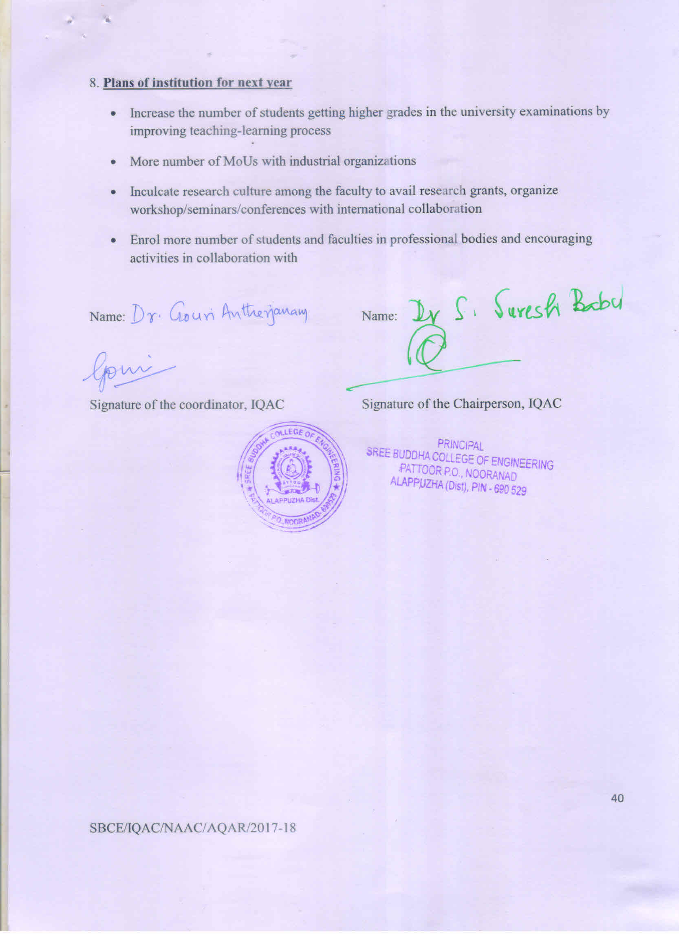

ANNEXURE - I
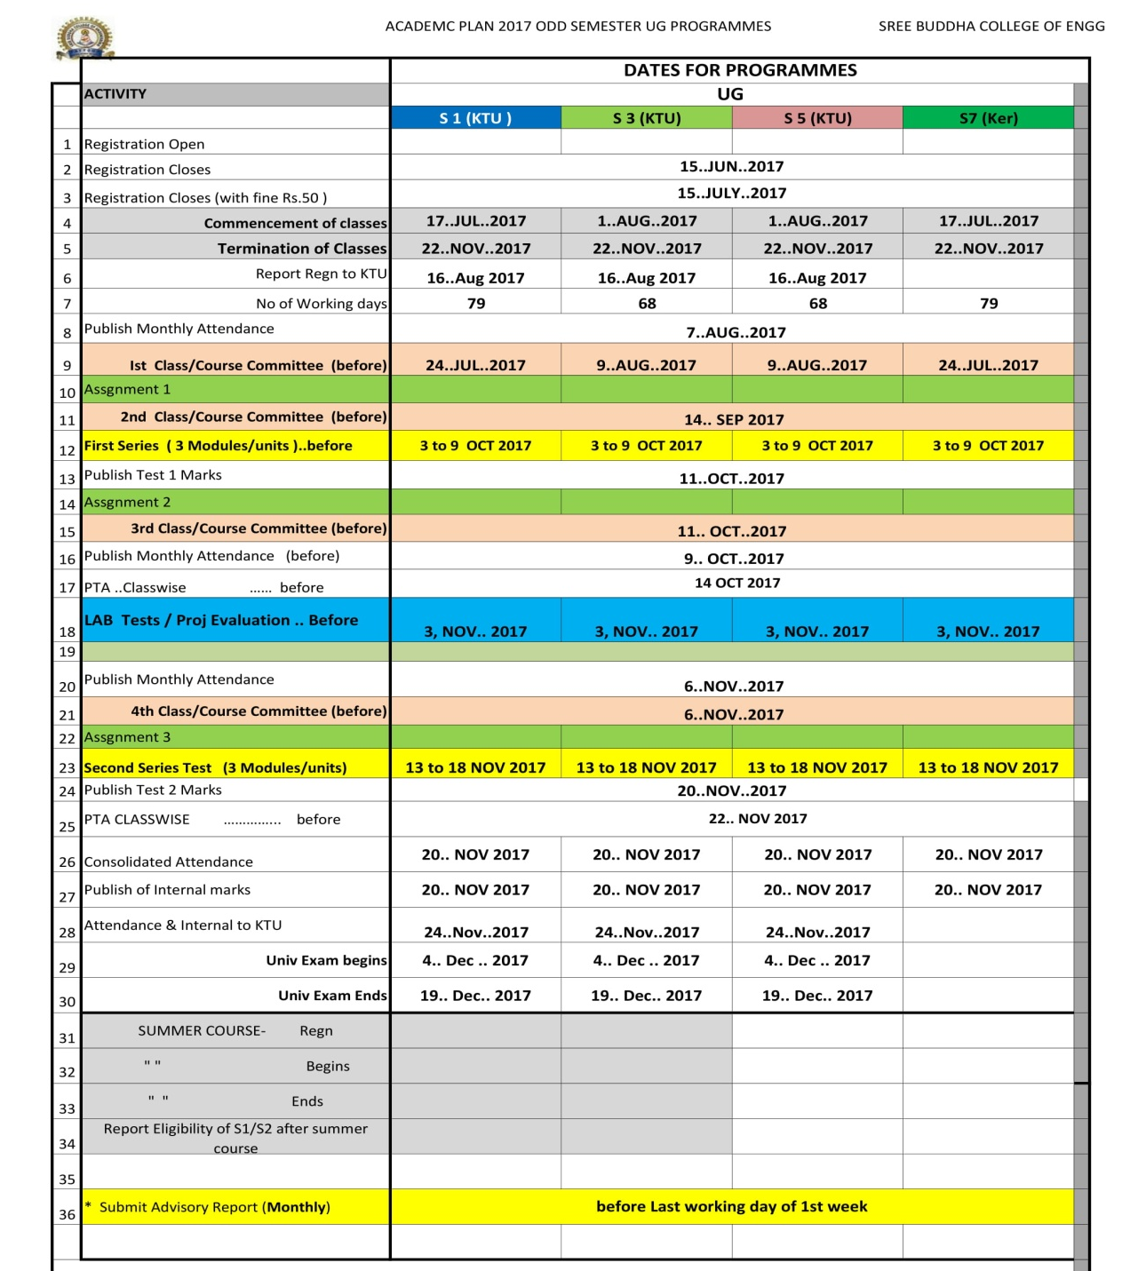
ACADEMIC CALENDER (ODD SEMESTER)

ANNEXURE - II
ACADEMIC CALENDER (EVEN SEMESTER)
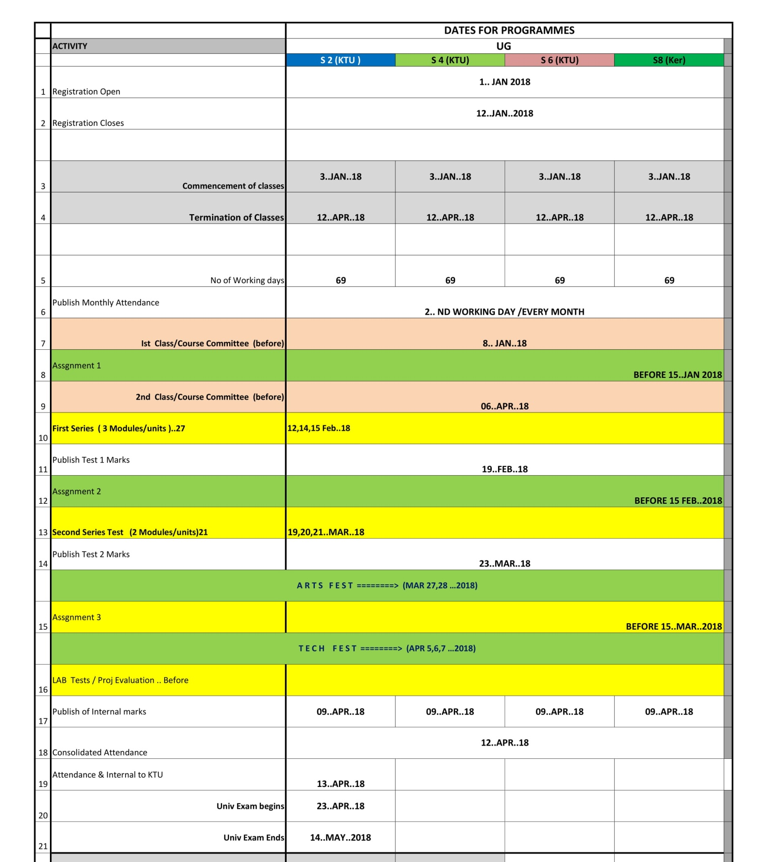

ANNEXURE III
FEEDBACK ANALYSIS

